**Batch: T5**

**Practical No. 3**

**Title of Assignment:Study of Java Script**

**Student Name:Trishul Balaso Patil**

**Student PRN:22510051**

**Problem Statement 1: Basics of Java Script**

**Write a JavaScript function that takes an array of numbers as input and returns the**

**sum of all even numbers in the array. Additionally, create a simple HTML interface with**

**an input field where the user can enter comma-separated numbers and a button to**

**trigger the calculation. Display the result below the button.**

**<!DOCTYPE html>**

**<html lang="en">**

**<head>**

**<meta charset="UTF-8" />**

**<meta name="viewport" content="width=device-width, initial-scale=1.0" />**

**<title>Sum of Even Numbers</title>**

**</head>**

**<body>**

**<h1>Sum of Even Numbers</h1>**

**<label for="numbers">Enter numbers (comma-separated):</label>**

**<input type="text" id="numbers" placeholder="e.g., 1,2,3,4,5" />**

**<button onclick="calculateSum()">Calculate Sum</button>**

**<p id="result"></p>**

**<script src="script.js">**

**function sumEvenNumbers(arr) {**

**return arr.reduce((sum, num) => {**

**return num % 2 === 0 ? sum + parseInt(num, 10) : sum;**

**}, 0);**

**}**

**function calculateSum() {**

**const input = document.getElementById("numbers").value;**

**const numberArray = input.split(",").map(Number);**

**const sum = sumEvenNumbers(numberArray);**

**document.getElementById("result").textContent = "Sum of even numbers: " + sum;**

**}**

**</script>**

**</body>**

**</html>**

**OutPut:**

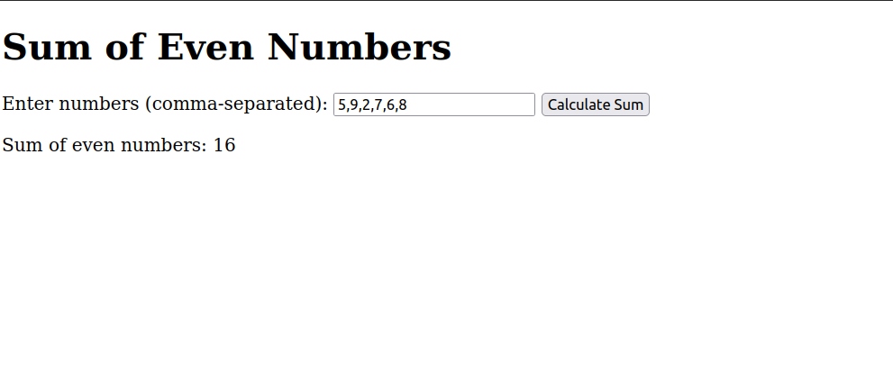

**Problem Statement 2: Implement a function that validates a password based on the**

**following criteria:**

**At least 8 characters long.**

**Contains at least one uppercase letter, one lowercase letter, one digit, and one**

**special character.**

**Create an HTML form with an input field for the password and a "Check Password"**

**button. Display a message indicating whether the password is valid or not.**

**Output:**

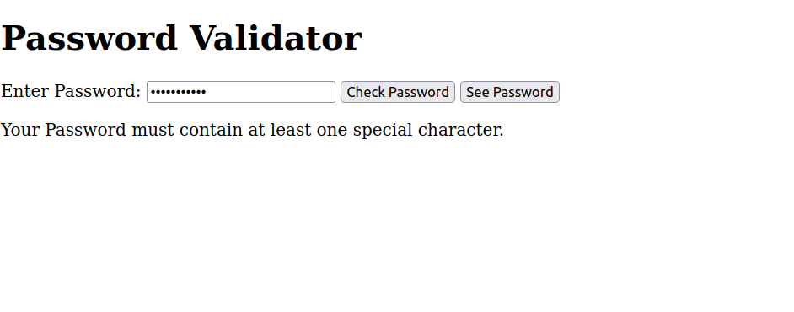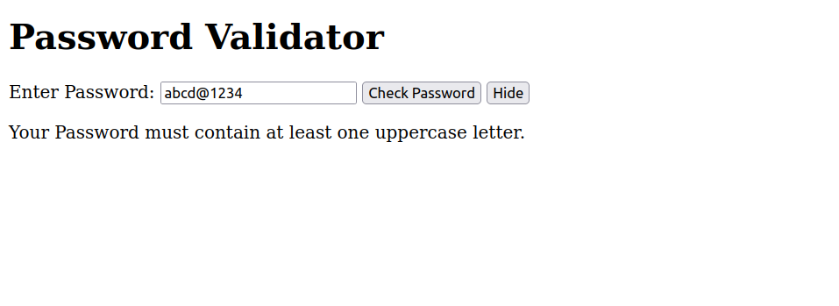

**Problem Statement 3: Web Development**

**Create a basic web page for a fictional online bookstore using HTML, CSS, and JavaScript.**

**The web page should have the following features:**

**A header with the bookstore name and a navigation menu (Home, Books, Contact).**

**An area to showcase featured books with their titles, authors, and cover images.**

**A section where all available books are displayed in a grid format. Each book should**

**have an image, title, author, and a button to "Add to Cart".**

**Implement a simple shopping cart functionality using JavaScript. Allow users to add**

**books to their cart and display the total number of items in the cart on the**

**navigation menu.**

**Problem Statement 4: Responsive Design**

**Implement responsive design techniques to make the website mobile-friendly.**

**Ensure that the navigation menu collapses into a hamburger menu on smaller**

**screens.**

**Adjust the layout and font sizes for optimal viewing on various devices.**

**OutPut:**

**Home Page**

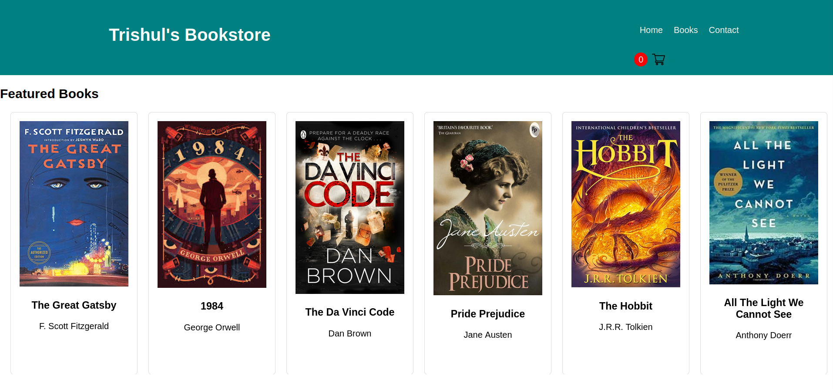

**Books Available**

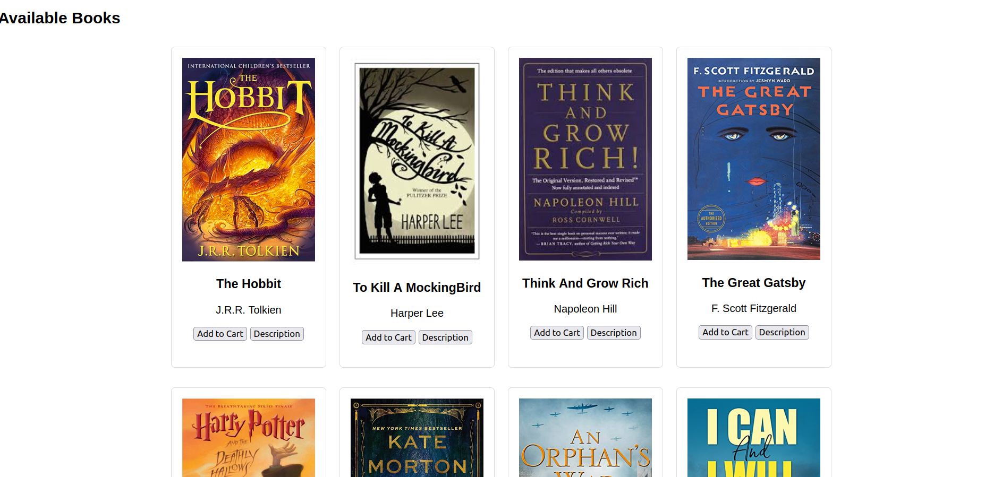

**Cart:**

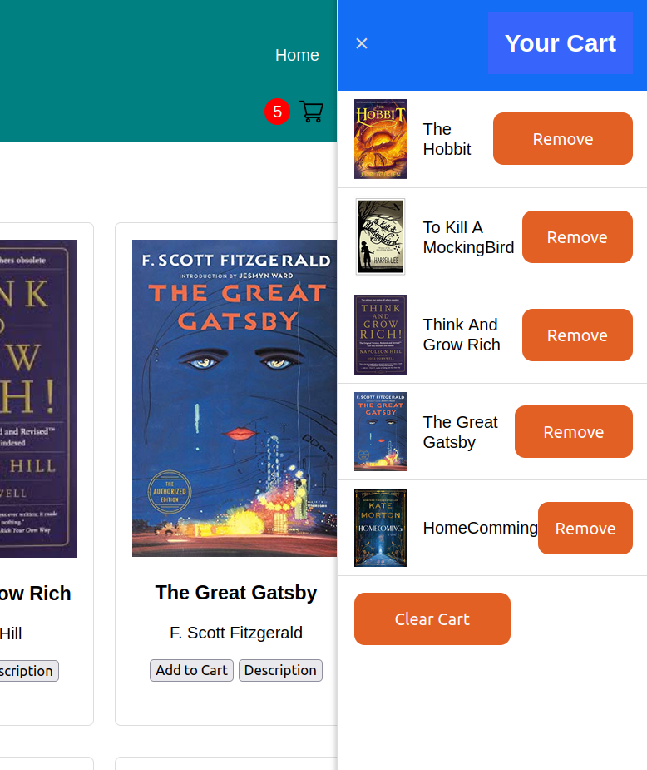

**Hamburger:**

